Unit 1: AC1.1-4
Hospitality Industry
LO1: Understand the environment in which hospitality and catering providers operate.
Marks: 15-29 |  | 17% – 32%
AC1.1 | AC1.2 | AC1.3 | AC1.4
Describe the structure of the hospitality and catering industry. | Analyse job requirements within the hospitality and catering industry. | Describe working conditions of different job roles across the hospitality and catering industry. | Explain factors affecting the success of hospitality and catering providers.
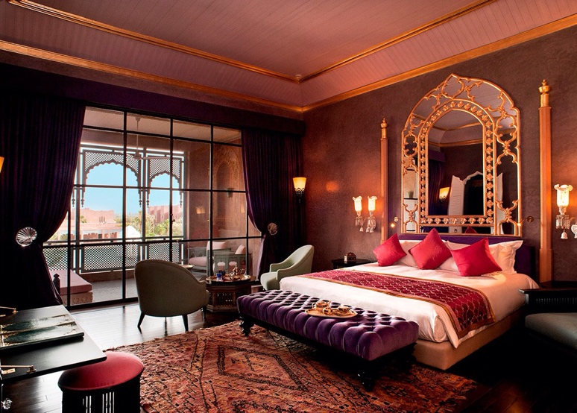
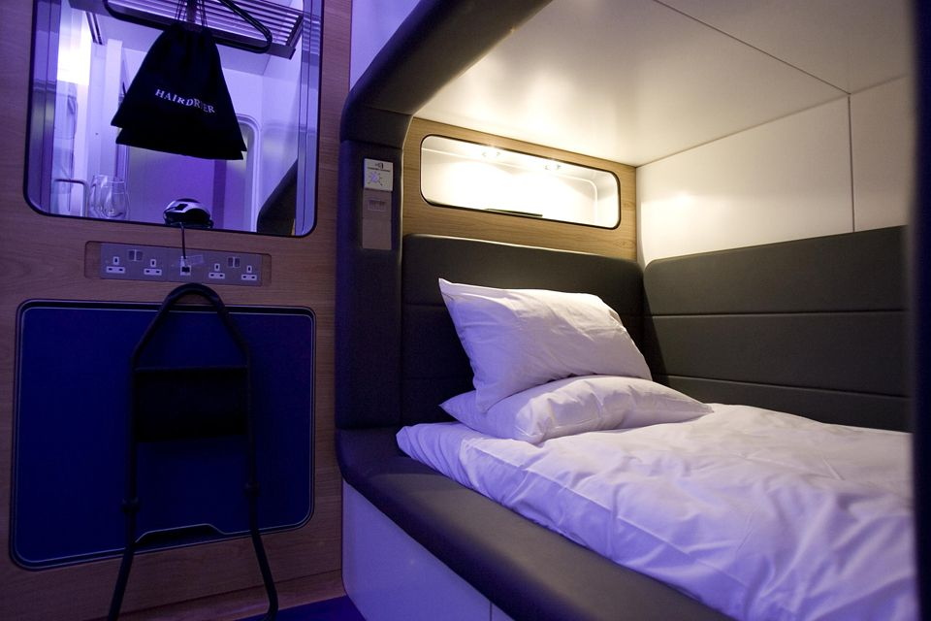
My Hospitality and Catering Business Proposal Part 1
Name: ............................................. Target Grade…………………………

List as many different types of bedroom accommodation as you can think of in the local areas e.g., Swiss Cottage, Castleton a guest house.

Take off task ……..

AC1.1 Types of Bedroom Accommodation

The type of customers you will attract to your hotel will depend on many factors, one of them being the types of bedroom accommodation that is on offer. This will also influence what you can charge too.
You need to show that you understand this by filling on the information below.

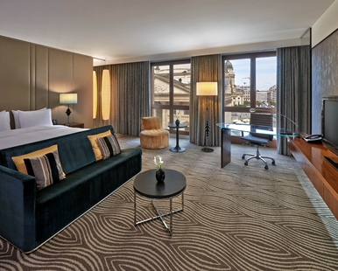
Hotel suite /deluxe suite Description/key Features of a Hotel suite:
…………………………………………………………………………….........................
…………………………………………………………………………….........................
…………………………………………………………………………….........................
…………………………………………………………………………….........................
…………………………………………………………………………….........................
…………………………………………………………………………….........................
……………………………………………………………………………………………………………………………………………….........................
……………………………………………………………………………………………………………………………………………….........................

Find an example of a room tariff (price per night) for a hotel suite somewhere in the UK and enter the details in the space below try and find the most expensive you can:
Hotel Location e.g., Central Liverpool
………………………………………………………………………………………………………………………………………………........................
Hotel Name e.g., Hilton Hotel
……………………………………………………………………………………………………………………………………………….........................
Room name or description: e.g. Executive Suite
……………………………………………………………………………………………………………………………………………….........................
Room tariff for tomorrows date e.g., £354 per night including breakfast
……………………………………………………………………………………………………………………………………………….........................
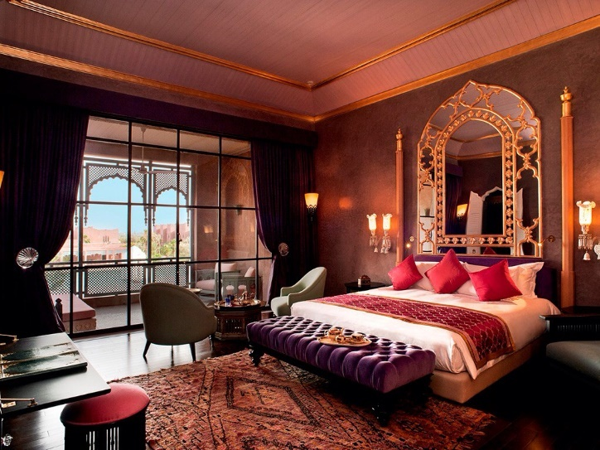
Boutique hotel
Description/key Features of a Boutique hotel:
……………………………………………………………….........................
……………………………………………………………….........................
……………………………………………………………….........................
……………………………………………………………….........................
……………………………………………………………….........................
……………………………………………………………….........................
…………………………………………………………….............................................................................................................
………………………………………………………………………………………………………………………………………………........................
……………………………………………………………………………………………………………………………………………...........................

Find an example of a room tariff (price per night) for a Boutique hotel room somewhere in the UK and enter the details in the space below:
Hotel Location: e.g. The Lake District
……………………………………………………………………………………………………………………………………………….........................
Hotel Name: e.g., Askham Hall
……………………………………………………………………………………………………………………………………………….........................
Room name or description: e.g., En-Suite King Sized Double
……………………………………………………………………………………………………………………………………………….........................
Room tariff for tomorrows date e.g., £250 per night including breakfast
……………………………………………………………………………………………………………………………………………….........................

Would you like to stay in this type of hotel room? Give reasons for you answer.
………………………………………………………………………………………………………………………………………………………………………………………………………………………………………………………………………………………………………………………………………………………………………………………………………………………………………………………………………………………………………………………………………………………………………………………………………………………………………………………………………………………………………………………………………………………………………………………………………………………………………………………………………………………………………………………………………………………………………………………………………………………………………………

Traditional Bed and Breakfast at holiday resort
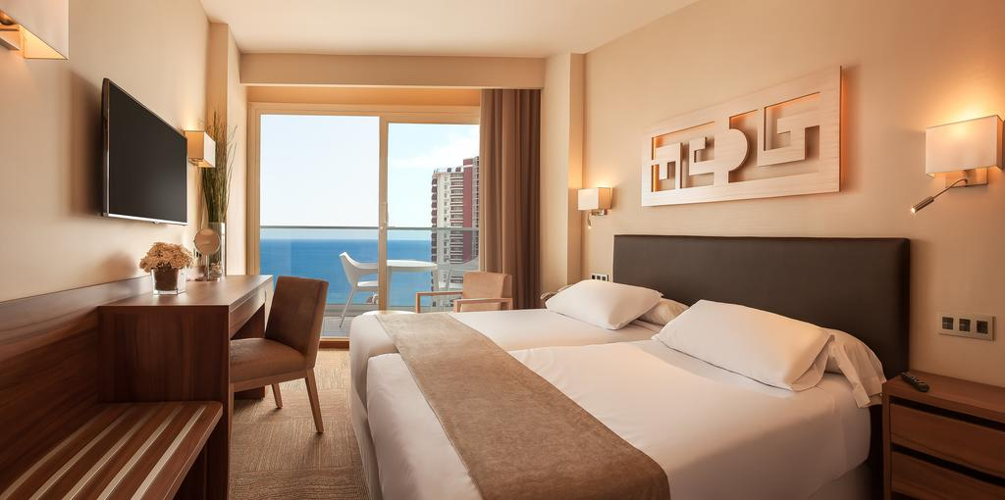
Description/key features of Traditional bread and breakfast accommodation:
…………………………………………………………….............................................................................................................
……………………………………………………………………………………………………………………………………………….........................
……………………………………………………………………………………………………………………………………………...........................
……………………………………………………………………………………………………………………………………………….........................
……………………………………………………………………………………………………………………………………………….........................
………………………………………………………………………………………………………………………………………………........................
………………………………………………………………………………………………………………………………………………........................
………………………………………………………………………………………………………………………………………………........................
………………………………………………………………………………………………………………………………………………........................
Find an example of a room tariff (price per night) for traditional Bed and Breakfast room somewhere in the UK and enter the details in the space below:
Hotel Location:
……………………………………………………………………………………………………………………………………………….........................
Hotel/Bed and Breakfast name:
……………………………………………………………………………………………………………………………………………….........................
Room name or description:
……………………………………………………………………………………………………………………………………………….........................
Room tariff for tomorrows date:
……………………………………………………………………………………………………………………………………………….........................

Who do you think would be the main types of customers to use this type of accommodation? Give reasons for you answer.
……………………………………………………………………………………………………………………………………………………………………………………………………………………………………………………………………………………………………………………………………………………………………………………………………………………………………………………………………………………………………………………………………………………………………………………………………………………………………………………………………………………………………………………………………………………………………………………………………………………………………………………………………………………………………………………………………………………………………………………………………………………………………………………………………………………………………………………………………………………………………………………………...........................

Motel/Budget Hotel
A Motel typically has rooms that have their own entrances on the outside of the building onto a balcony or patio area, where as a hotel will have an indoor corridor. A Motel is usually no more than a two-story building as a hotel can be multi-storey.

Once inside the rooms are more basic than a boutique or hotel suite but often have the following characteristics:
- Comfortable king-sized beds with good quality duvets and pillows.
- En-suite bathrooms with shower gel.
- Remote control TVs. Tea- and coffee-making facilities.
- Hairdryers.
- Heater control.
- Spacious desk area with Internet access.
- Family rooms, with cots on request.
- 24-hour reception.
- Restaurant and licensed bar nearby.
- Hot breakfast available in or nearby.

Prices in this type of hotel vary greatly depending on the area that they are in e.g. city centre, airport, sea-side location, nearby events, time of year, day of the week etc. the more demand the higher the price.

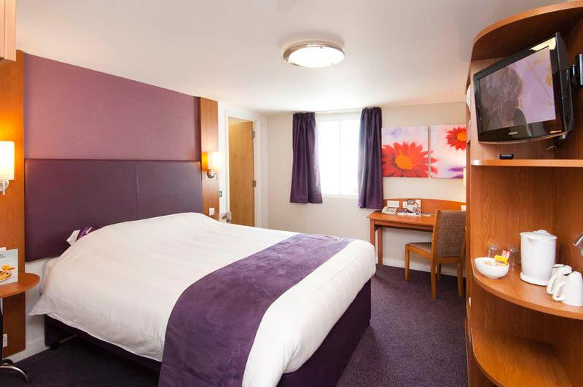

Examples

Hotel Name | Location | Price per double room per night booking for Friday May 4th
Leicester Square Premier Inn | Central London close to Trafalgar Square, Soho, China Town and Covent Garden | £182
John Lennon Airport Premier Inn | Outskirts of Liverpool right beside the airport a short trip to the Echo Arena and Anfield. | £67
Kings Lynn | Near the River Ouse on the Outskirts of the historic town of Kings Lynn. | £60
Great Yarmouth | A short drive from the seafront and perfectly located for exploring the Norfolk Broads. | £96.50

To show you understand the industry, use the data and information on the previous page to help you answer the following questions.

Example question and answer:

Would you expect customers to book their main family holiday in a Budget Hotel/ Motel such as Premier Inn?

I would not expect many families would pick this as their 1st option for a holiday. The majority of the time this type of hotel is used for shorter trips and breaks rather than for a holiday of 7 days or more. But, it would depend on the location. From the data provided I would expect a family to be more likely to book a main holiday at the hotel in Great Yarmouth because of the proximity to the beach. Whilst guests booking at John Lennon would book due to its proximity to the airport so would holiday elsewhere. Being close to the airport, it would not be a peaceful break. Families would be more likely to stop there just for one or two nights to explore the city or go to and event as the data mentions two venues. Central London would be less likely as it is more expensive to stop there in a basic room than some all-inclusive holidays abroad. I cannot see that a family would book in a location such as Kings Lynn as there is not enough data to suggest there is a lot to do near-by. Looking at the characteristics of this type of accommodation in general, some family friendly facilities are on offer such as a cot on request, but it could prove difficult and/or expensive to stop with children as there is no free entertainment for children or cooking facilities. I would therefore expect families on a higher budget to select a hotel with additional facilities and those on a lower budget to opt for a caravan holiday, book self-catering accommodation or to use a holiday park e.g. Butlins for the Children’s entertainment.

Read back over the rest of your work and check that your other answers are up to this standard- add to or correct and then carry on

What facilities are offered that would suggest that this type of accommodation is used by business customer?
………………………………………………………………………………………………………………………………………………………………………………………………………………………………………………………………………………………………………………………………………………………………………………………………………………………………………………………………………………………………………………………………………………………………………………………………………………………………………………………………………………………………………………………………………………...........................................................................................................................

Why do you think that the hotel in London is the most expensive?
………………………………………………………………………………………………………………………………………………………………………………………………………………………………………………………………………………………………………………………………………………………………………………………………………………………………………………………………………………………………………………………………………………………………………………………………..................................................................................................

Why do you think the hotel in Kings Lynn is the least expensive?
………………………………………………………………………………………………………………………………………………………………………………………………………………………………………………………………………………………………………………………………………………………………………………………………………………………………………………………………………………………………………………………………………………………………………………………………..................................................................................................

Who do you think would be the main type of customer using the Great Yarmouth hotel and why would they pick that hotel?
………………………………………………………………………………………………………………………………………………………………………………………………………………………………………………………………………………………………………………………………………………………………………………………………………………………………………………………………………………………………………………………………………………………………………………………………………………………………………………………………………………………………………………………………………………………………………………………………………………………………………………………………………

Cabin room at airports (Yotel)
Description/Key features of cabin rooms
…………………………………………………………………........................
…………………………………………………………………........................
…………………………………………………………………........................
………………………………………………………………...........................
………………………………………………………………...........................
………………………………………………………………...........................
………………………………………………………………...........................
………………………………………………………………...........................
…………………………………………………………………........................
………………………………………………………………...........................
……………………………………………………………………………………………………………………………………………………………………………………………………………………………………………………………………………………………….................................................

Why do you think customers would pick this type of room?
……………………………………………………………………………………………………………………………………………………………………………………………………………………………………………………………………………………………………………………………………………………………………………………………………………………………………………………………………………………………………………………………………………………………………………………………………………………………………………………………………………………………………………………………………………………………………………………………………………………………………………………………………………………………………………………………………………………………………………………………………………………………………………..

What are the main advantages and disadvantages of this type of accommodation?

Advantages | Disadvantages

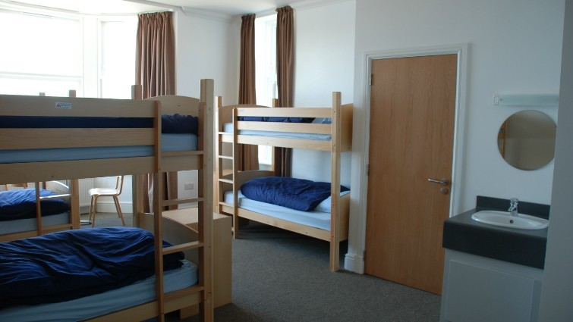
Youth hostel (YHA) and Bunk Houses
Description/Key features of a Youth Hostel or Bunk House.
…………………………………………………………........................
…………………………………………………………........................
…………………………………………………………........................
…………………………………………………………........................
…………………………………………………………........................
…………………………………………………………........................
…………………………………………………………........................
…………………………………………………………........................
………………………………………………………………………………………………………………………………………………………………………………………………………………………………………………………………………………………………………………………………………………………………………………………………………………………………………………………………………………………………………………………………………………………………………………………………..................................................................................................

What type of customers do you think would pick a Youth Hostel or Bunk House? Explain why you think they would pick it.
………………………………………………………………………………………………………………………………………………………………………………………………………………………………………………………………………………………………………………………………………………………………………………………………………………………………………………………………………………………………………………………………………………………………………………………………………………………………………………………………………………………………………………………………………………………………………………………………………………………………………………………………………………………………………………………………………………………………………………………………………………………………………………………………………………………………………………………………………………………………………………………………………………………………………………………………………………………………………………………………………………………………………………………………………………………………………………………………………………………………..........................................................................

Homework - AC1.1 Standards, Reviews and Ratings
What are the benefits of ratings?

What is a rating system and why are they used?
……………………………………………………………………………………………………………………………………………………………………………………………………………………………………………………………………………………………………………………………………………………………………………………………………………………………………………………………………………………………………………………………………………………………………………………………………………………………………………………………………………………………………………………………………………………………………………………………………………………………………………………………………………………………………………………………………………………………………………………………………………………………………………………………………………………………………………………………………………………………………………………………….........................

Produce a spider diagram that shows all the benefits of rating systems

The benefits of a rating system

