Unit 1: AC1.1-4
Hospitality Industry
LO1: Understand the environment in which hospitality and catering providers operate.
Marks: 15-29 |  | 17% – 32%
AC1.1 | AC1.2 | AC1.3 | AC1.4
Describe the structure of the hospitality and catering industry. | Analyse job requirements within the hospitality and catering industry. | Describe working conditions of different job roles across the hospitality and catering industry. | Explain factors affecting the success of hospitality and catering providers.
My Hospitality and Catering Business Proposal Part 4
Name: ............................................. Target Grade…………………………

Take off task ……..
How many job roles in the catering industry can you identify?

AC1.1 Kitchen Organisation: Purpose
What is the purpose of organising your kitchen? Make sure you fully explain your answer to show your understanding.

- To produce the right quantity of food (for the right number of people). This is important because: ………………………………………………………………………………………………………………………………………………………………………………………………………………………………………………………………………………………………………………………………………………………………………………………………………………
- To produce food to the required standard. This is important because: ………………………………………………………………………………………………………………………………………………………………………………………………………………………………………………………………………………………………………………………………………………………………………………………………………………
- To produce food on time. This is important because: ………………………………………………………………………………………………………………………………………………………………………………………………………………………………………………………………………………………………………………………………………………………………………………………………………………
- To make the most effective use of staff, materials and equipment. This is important because: ………………………………………………………………………………………………………………………………………………………………………………………………………………………………………………………………………………………………………………………………………………………………………………………………………………

Add any additional reasons that you can think of that will explain why it is important to be organised in the kitchen:
………………………………………………………………………………………………………………………………………………………………………………………………………………………………………………………………………………………………………………………………………………………………………………………………………………………………………………

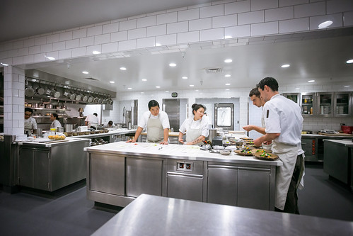

AC1.1 Kitchen Organisation: Planning
Write 4 paragraphs to explain why planning is important for kitchen organisation.
………………………………………………………………………………………………………………………………………………………………………………………………………………………………………………………………………………………………………………………………………………………………………………………………………………………………………………………………………………………………………………………………………………………………………………………………………………………………………………………………………………………………………………………………………………………………………………………………………………………………………………………………………………………………………………………………………………………………………………………………………………………………………………………………………………………………………………………………………………………………………………………………………………………………………………………………………………………………………………………………………………………………………………………………………………………………………………………………………………………………………………………………………………………………………………………………………………………………………………………………………………………………………………………………………………………………………………………………………………………………………………………………………………………………………………………………………………………………………………………………………………………………………………………………………………………………………………………………………………………………………………………………………………………………………………………………………………………………………………………………………………………………………………………………………………………………………………………………………………………………………………………………………………………………………………………………………………………………………………………………………………………………………………………………………………………………………………………………………………………………………………………………………………………………………………………………………………………………………………………………

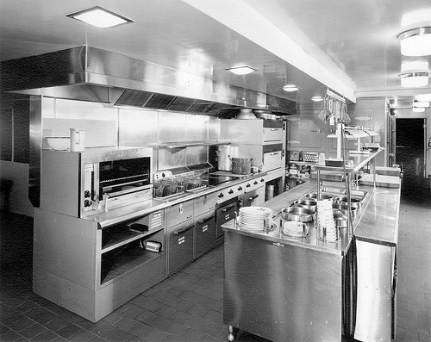

AC1.1 Kitchen Organisation: Partie System
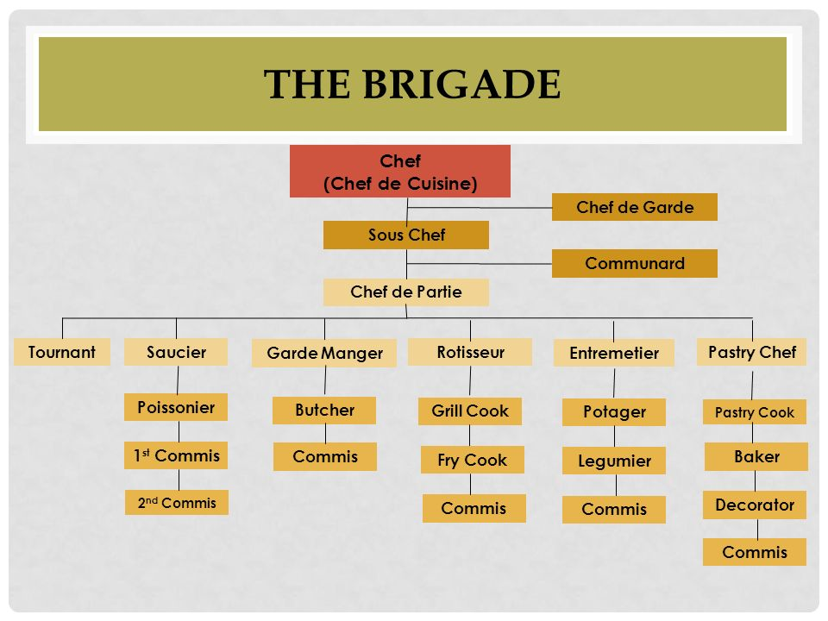

Produce a spider diagram to show all the factors that you would need to take into account when deciding on what staff you would need in the kitchen.

Factors

AC1.1 Kitchen Organisation: Staffing Hierarchy
Produce a diagram to show the hierarchy you will have in your hotel kitchen in the space below.

AC1.1 Hospitality Hierarchy

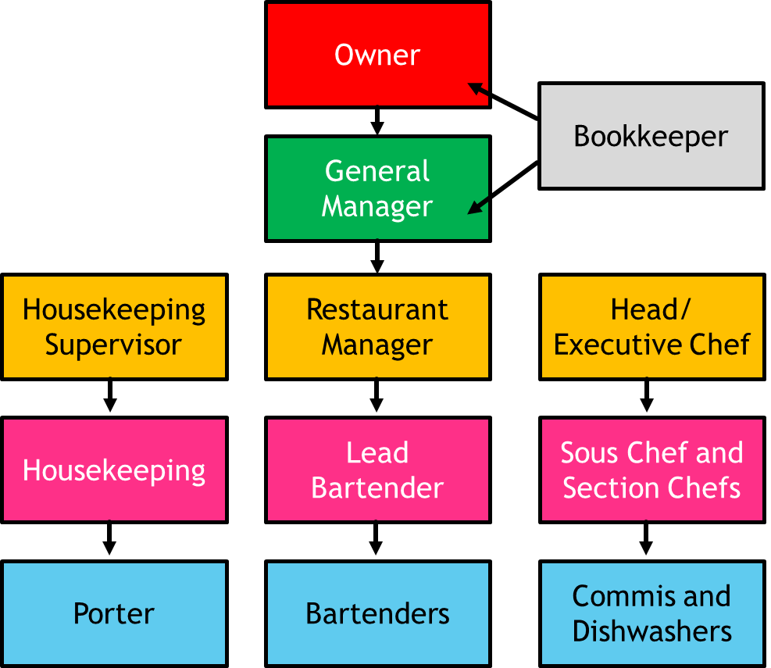

Explain why there needs to be a hierarchy in the hospitality and catering industry.
………………………………………………………………………………………………………………………………………………………………………………………………………………………………………………………………………………………………………………………………………………………………………………………………………………………………………………………………………………………………………………………………………………………………………………………………………………………………………………………………………………………………………………………………………………………………………………………………………………………………………………………………………………………………………………………………………………………………………………………………………………………………………………………………………………………………………………………………………………………………………………………………

AC1.1 and AC1.2 Job Roles
It is now time to decide who you would need to employ in your hotel. To make it easier to staff your hotel it is broken down into areas for you. You will need to do some independent research to be able to complete this task. Attach your work to the back of the booklet

Kitchen Brigade
Front of House -Restaurant and Bar
Hotel Front of House- Concierge, Reception and guest services
Office and administration staff
House-keeping, grounds and maintenance staff

Kitchen Brigade
Job Title | Alternative title | Main responsibilities | Qualifications needed & Expected pay/wages
Head Chef | Executive Chef  Kitchen Manager | Must be an experienced chef as this is a mainly supervisorial role, managing the business aspects of the kitchen including money/costings, food orders, record keeping and checking paperwork has been completed correctly, creating the menus, and directing the staff in their duties and management of the staff. In larger restaurants or hotels the executive chef is more of a figurehead whose day-to-day work involves little active cooking. | City & guilds diploma L3 in professional cookery - £20,000 and upwards depending on the size of the establishment, responsibilities and location.
Front of House -Restaurant and Bar
Hotel Front of House- Concierge, Reception and guest services
Office and administration staff
House-keeping, grounds and maintenance staff

Homework - AC1.1 and AC1.2 Job Roles

Front of house = staff the guests see and come into contact with.

Back of house= staff that work behind the scenes and largely out of site of the guests.

- Write 2 job adverts for jobs available in your hotel.

- Pick 1 front of house role and one kitchen role to advertise

Wanted ________________________________________ to work in a busy hotel kitchen.

Salary ________________________________

Responsibilities:
………………………………………………………………………………………………………………………………………………………………………………………………………………………………………………………………………………………………………………………………………………………………………………………………………………………………………………………………………………………………………………………………………………………………………………………………
Essential qualifications and experience:
………………………………………………………………………………………………………………………………………………………………………………………………………………………………………………………………………………………………………………………………………………………………………………………………………………………………………………………………………………………………………………………………………………………………………………………………………………………………………………………………………………………………………………………………………………

Desirable personal qualities and abilities:
………………………………………………………………………………………………………………………………………………………………………………………………………………………………………………………………………………………………………………………………………………………………………………………………………………………………………………………………………………………………………………………………………………………………………………………………………………………………………………………………………………………………………………………………………………

Wanted ________________________________________ to work front of house in a busy hotel _____________________________.

Salary ________________________________

Responsibilities:
………………………………………………………………………………………………………………………………………………………………………………………………………………………………………………………………………………………………………………………………………………………………………………………………………………………………………………………………………………………………………………………………………………………………………………………………

Essential qualifications and experience:
………………………………………………………………………………………………………………………………………………………………………………………………………………………………………………………………………………………………………………………………………………………………………………………………………………………………………………………………………………………………………………………………………………………………………………………………………………………………………………………………………………………………………………………………………………
Desirable personal qualities and abilities:
………………………………………………………………………………………………………………………………………………………………………………………………………………………………………………………………………………………………………………………………………………………………………………………………………………………………………………………………………………………………………………………………………………………………………………………………………………………………………………………………………………………………………………………………………………

AC1.2: Exam questions

Suggest 3 important qualities a restaurant manager would look for when appointing new wait staff. (3 marks)
…………………………………………………………………………………………………………………………………………………………………………………………………………………………………………………………………………………………………………………………………………………………………………………………………………………………………………………………………………………………………………………………………………………………………………………………………………………………………………………………………………………………

Describe the duties of wait staff in a busy restaurant. (3 marks)
………………………………………………………………………………………………………………………………………………………………………………………………………………………………………………………………………………………………………………………………………………………………………………………………………………………………………………………………………………………………………………………………………………………………………………………………………………………………………………………………………………………..

Outline the main qualities of a successful chef. (5 marks)
……………………………………………………………………………………………………………………………………………………………………………………………………………………………………………………………………………………………………………………………………………………………………………………………………………………………………………………………………………………………………………………………………………………………………………………………………………………………………………………………………………………………………………………………………………………………………………………………………………………………………………………………………………………………………………………………………………………………………………………………………………………………………………………………………………………………………………………………………………………………………………………………………………………………………………..

