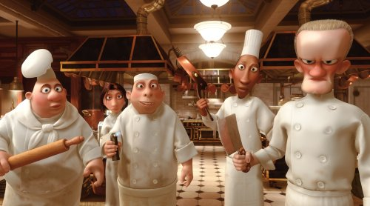
Unit 1: AC1.1-4
Hospitality Industry
My Hospitality and Catering Business Proposal Part 1
Name: ............................................. Target Grade…………………………

LO1: Understand the environment in which hospitality and catering providers operate.
Marks: 15-29 |  | 17% – 32%
AC1.1 | AC1.2 | AC1.3 | AC1.4
Describe the structure of the hospitality and catering industry. | Analyse job requirements within the hospitality and catering industry. | Describe working conditions of different job roles across the hospitality and catering industry. | Explain factors affecting the success of hospitality and catering providers.

Take off task ……..
What is the minimum living wage for ....
- 18 plus? ............................ per hour
- Under 18? ........................ per hour
- Apprentice? ...................... per hour

AC1.2, 2.1, 2.2,3.1: Employers’ rights and responsibilities

When employing staff for your hotel you become and employer. What responsibilities do employers have?
………………………………………………………………………………………………………………………………………………………………………………………………………………………………………………………………………………………………………………………………………………………………………………………………………………………………………………………………………………………………………………………………………………………………………………………………………………………………………………………………………………………………………………………………………………………………………………………………………………………………………………………………………………………………

The staff that you employ are your employees. What responsibilities do employees have in addition to their Job role?
………………………………………………………………………………………………………………………………………………………………………………………………………………………………………………………………………………………………………………………………………………………………………………………………………………………………………………………………………………………………………………………………………………………………………………………………………………………………………………………………………………………………………………………………………………………………………………………………………………………………………………………………………………………………

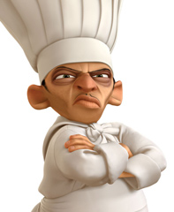

AC1.2, 2., 2.2, 3.1: Regulation and Protection
Employers and people in employment are subject to a variety of legislation. Produce a spider diagram of the main areas covered by legislation.

Legislation

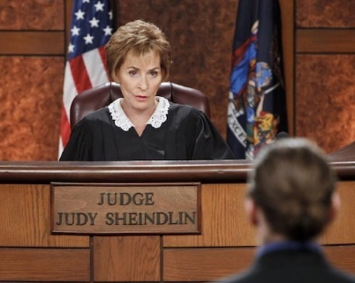

AC1.2: Learning and Qualifications
Write a paragraph to explain how you will ensure that you keep you and your employees knowledge and skills up to date.
……………………………………………………………………………………………………………………………………………………………………………………………………………………………………………………………………………………………………………………………………………………………………………………………………………………………………………………………………………………………………………………………………………………………………………………………………………………………………………………………………………………………………………………………………………………………………………………………………………………………………………………………………………………………………………………………………………………………………………………………………………………………………………………………………………………………………………………………………………………………………………………………………………………………………………………………………………………………………………………………………………..

AC1.2: Professional Bodies

Which professional body do you think it would be best to join when you open your hotel? Explain your reason for choice.
………………………………………………………………………………………………………………………………………………………………………………………………………………………………………………………………………………………………………………………………………………………………………………………………………………………………………………………………………………………………………………………………………………………………………………………………………………………………………………………………………………………………………………………………………………………………………………………………………………………………………………………………………………………………………………………………………………………………………………………………………………………………………………………………………………………………………………………………………………………………………………………………

AC1.3: describe working conditions of different job roles across the hospitality and catering industry.

AC1.3: Contract Types in Brief

What is a contract?
………………………………………………………………………………………………………………………………………………………………………………………………………………………………………………………………………………………………………………………………………………………………………………………………………………………………………………
………………………………………………………………………………………………………………………………………………

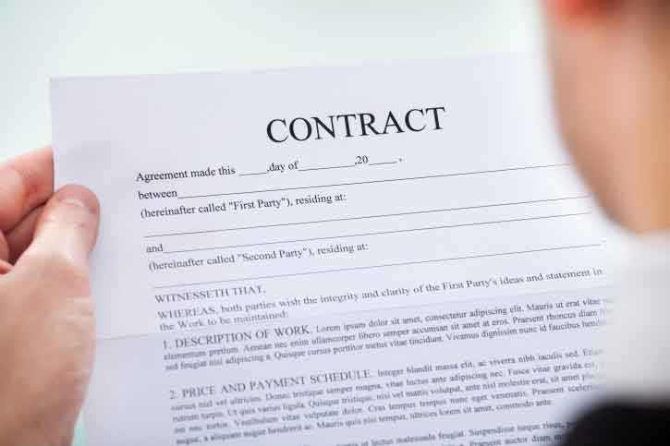

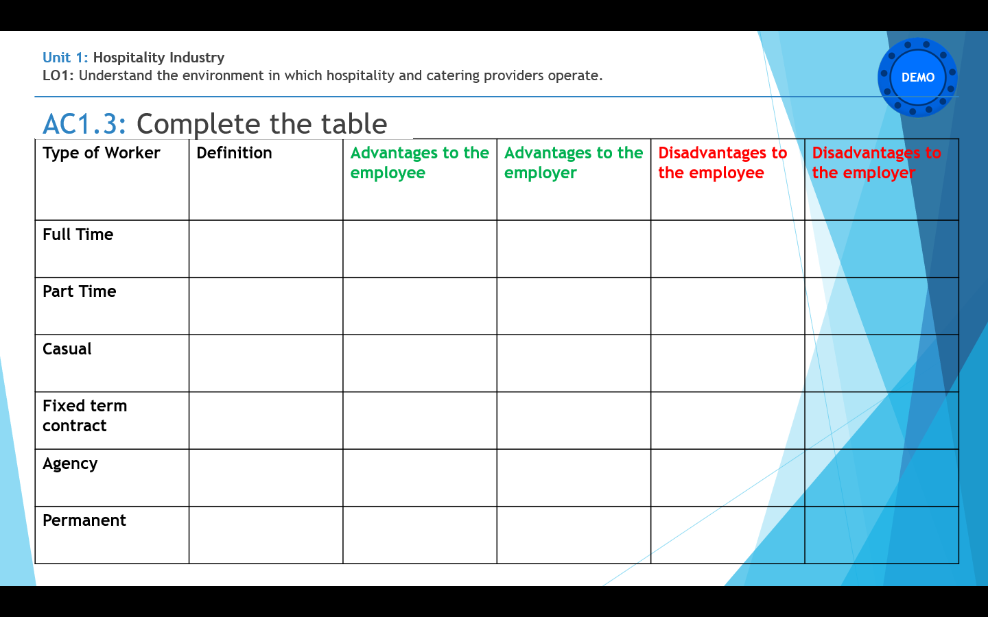

AC1.3: What type of contract would you give to each of the following people? Explain why you think it is the best choice.

Executive Chef
………………………………………………………………………………………………………………………………………………………………………………………………………………………………………………………………………………………………………………………………………………………………………………………………………………………………………………………………………………………………………………………………………………………………………………………………………………………………………………………………………………………………………………………………………………………………………………………………………………………………………………………………………………………………………………………………………………………………………………………………………………………………………………

Waiter/waitress
……………………………………………………………………………………………………………………………………………………………………………………………………………………………………………………………………………………………………………………………………………………………………………………………………………………………………………………………………………………………………………………………………………………………………………………………………………………………………………………………………………………………………………………………………………………………………………………………………………………………………………………………………………………………………………………………………………………………………………………………………………………………………………...

Cleaner/ Chamber Maid
……………………………………………………………………………………………………………………………………………………………………………………………………………………………………………………………………………………………………………………………………………………………………………………………………………………………………………………………………………………………………………………………………………………………………………………………………………………………………………………………………………………………………………………………………………………………………………………………………………………………………………………………………………………………………………………………………………………………………………………………………………………………………………..

AC1.3: Holiday Entitlement – Your Rights

How much holiday would you give to you full time staff and part time staff? Give reasons for your answers.
……………………………………………………………………………………………………………………………………………………………………………………………………………………………………………………………………………………………………………………………………………………………………………………………………………………………………………………………………………………………………………………………………………………………………………………………………………………………………………………………………………………………………………………………………………………………………………………………………………………………………………………………………………………………………………………………………………………………………………………………………………………………………………………………………………………………………………………………………………………………………………………………………………………………………………………………………………………………………………………………………………..

AC1.3: Holiday Pay – Your Rights
How much holiday pay would you expect to give to your employees? Give reasons for your answers.
……………………………………………………………………………………………………………………………………………………………………………………………………………………………………………………………………………………………………………………………………………………………………………………………………………………………………………………………………………………………………………………………………………………………………………………………………………………………………………………………………………………………………………………………………………………………………………………………………………………………………………………………………………………………………………………………………………………………………………………………………………………………………………………………………………………………………………………………………………………………………………………………..

AC1.3: Tip Culture and Bonuses

What policy will you have for giving tips and bonuses in your hotel? Give reasons for your answer
………………………………………………………………………………………………………………………………………………………………………………………………………………………………………………………………………………………………………………………………………………………………………………………………………………………………………………………………………………………………………………………………………………………………………………………………………………………………………………………………………………………………………………………………………………………………………………………………………………………………………………………………………………………………………………………………………………………………………………………………………………………………………………………………………………………………………………………………………………………………………………………………………………………………………………………………………..

Will you add a service charge in your bars and restaurant? Give reasons for your answer.
…………………………………………………………………………………………………………………………………………………………………………………………………………………………………………………………………………………………………………………………………………………………………………………………………………………………………………………………………………………………………………………………………………………………………………………………………………………………………………………………………………………………………………………………………………………………………………………………………………………………………………………………………………………………

