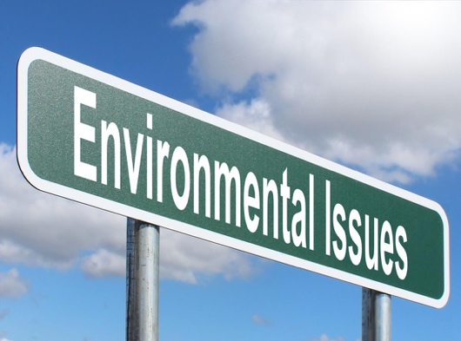
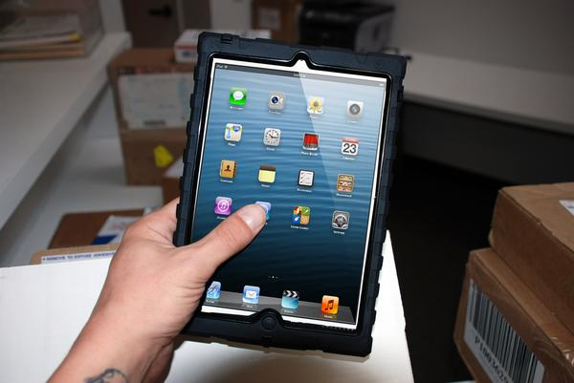
Unit 1: AC1.1-4
Hospitality Industry
My Hospitality and Catering Business Proposal Part 7
Name: ............................................. Target Grade…………………………

LO1: Understand the environment in which hospitality and catering providers operate.
Marks: 15-29 |  | 17% – 32%
AC1.1 | AC1.2 | AC1.3 | AC1.4
Describe the structure of the hospitality and catering industry. | Analyse job requirements within the hospitality and catering industry. | Describe working conditions of different job roles across the hospitality and catering industry. | Explain factors affecting the success of hospitality and catering providers.

Take off task ……..
What factors could affect the success of your hospitality and catering establishment?

AC1.4: The Economy
What is the economy?
………………………………………………………………………………………………………………………………………………………………………………………………………………………………………………………………………………………………………………………………………………………………………………………………………………………………………………………………………………………………………………………………………………………………………………………………

AC1.4: Recession
What is a recession? Why do you think this could affect your hotel?
………………………………………………………………………………………………………………………………………………………………………………………………………………………………………………………………………………………………………………………………………………………………………………………………………………………………………………………………………………………………………………………………………………………………………………………………………………………………………………………………………………………………………………………………………………………………………………………………………………………………………………………………………………………………………………………………………………………………………………………………………………………………………………………………………………………………………………………………………………………………………………………………

AC1.4: Tax and VAT
How could Tax and VAT influence the amount of profit that your hotel could make?
………………………………………………………………………………………………………………………………………………………………………………………………………………………………………………………………………………………………………………………………………………………………………………………………………………………………………………

How much VAT will your hotel have to add on to the sale of food and drinks?
………………………………………………………………………………………………………………………………………………

What other taxes do you think your hotel will have to pay?
………………………………………………………………………………………………………………………………………………………………………………………………………………………………………………………………………………………………………………………………………………………………………………………………………………………………………………

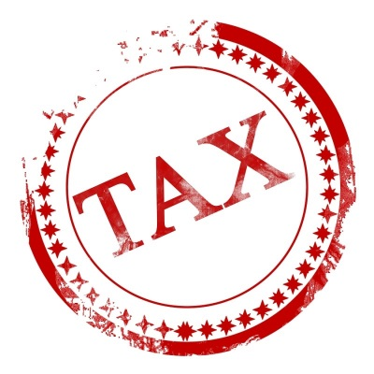

AC1.4: BREXIT
List the advantages and disadvantages of the UK now not being part of the European Union. The table is included on the next page of your booklet.

Advantages of leaving the European Union | Disadvantages of leaving the European Union

How do you think not being part of the EU may influence who uses your hotel and/or how much they spend?
………………………………………………………………………………………………………………………………………………………………………………………………………………………………………………………………………………………………………………………………………………………………………………………………………………………………………………………………………………………………………………………………………………………………………………………………………………………………………………………………………………………………………………………………………………………………………………………………………………………………………………………………………………………….....

AC1.4: The 6Rs

When you are setting up a business it is essential to follow current trends. Customers are looking for a more environmentally friendly experience. The government is also focusing on this, especially a reduction in the use of plastic e.g. plastic straws. It is essential that you are able to show your understanding of environmental issues if you are to secure a bank loan to set up your hotel.

Can you identify the 6 R’s?
- …………………………………………………………….
- …………………………………………………………….
- …………………………………………………………….
- …………………………………………………………….
- ……………………………………………………………
- ……………………………………………………………

On the next page, show your ideas of how you can be more environmentally friendly in your hotel, bar and restaurant. You will need to carry out some independent research to get ideas.

The 6Rs | Ideas on how your hotel can be more environmentally friendly
Reduce

Re-use

Recycle

Rethink

Repair

Refuse

Mind map the ways we can conserve energy and water whilst discussing as a class.

Conserving Energy & Water

AC1.4: Conserving Energy
Exam practice
Rosa wants to improve her hotel’s reputation for being ‘environmentally friendly’. Suggest ways the hotel could achieve this when preparing, cooking and serving food. (9 marks)
- Preparing (3)
- Cooking (3)
- Serving (3)

...........................................................................................................................................................................................................................................................................................................................................................................................................................................................................................................................................................................................................................................................................................................................................................................................................................................................................................................................................................................................................................................................................
...............................................................................................................................................................................................................................................................................................................................................................................................................................................................................................................................................................................................................

AC1.4/2.1/2.2: Technology

The introduction of new technologies could affect your hotel. If new technology is being adopted by your competitors they will take over and it will be difficult for you to compete. For example not being able to book on line can put a company at a disadvantage.
Technology can be expensive, so you must think carefully which are worth paying for, or to pay staff to keep up to date.

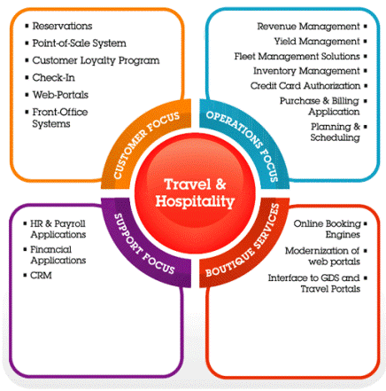

To show your bank manager that you understand new and emerging technologies prioritise your top 5 purchases/use on the next page of your business plan.

Item | Function (the job it will do) | Advantages | Disadvantages

AC1.4/2.1/2.2: Technology- Apps

Although many apps are free to users/customers a business will have to pay to be included in their listings

Investigate the range of apps available to help manage your hotel, and that customers may use to find information about your establishment or to make a booking.

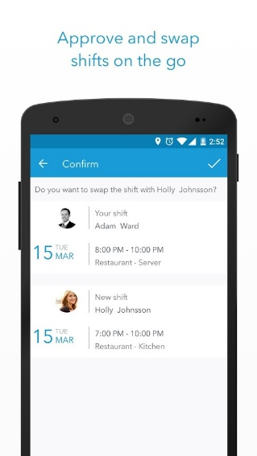
Use the space below to give information about your top 3 apps relevant to your hotel.
Record the name of the app and give a brief outline of what it does.

My top 3 Apps
- ………………………………………………………………………………………………………………………………………………………………………………………………………………………………………………………………………………………………………………………………………………………………………………………………………………
- ………………………………………………………………………………………………………………………………………………………………………………………………………………………………………………………………………………………………………………………………………………………………………………………………………………
- ………………………………………………………………………………………………………………………………………………………………………………………………………………………………………………………………………………………………………………………………………………………………………………………………………………
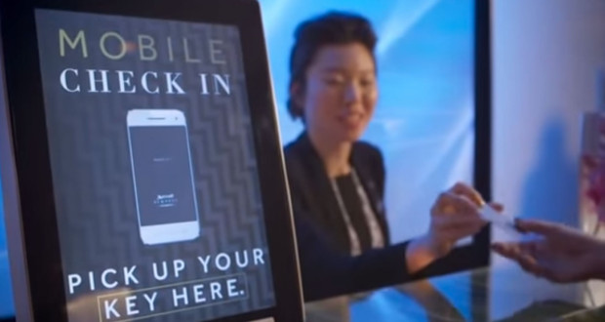
AC1.4: Technology
Exam practice
As a manager of a small restaurant you have recently acquired a new computer. Explain how this computer could be used to assist the running of the restaurant. (6 marks)
....................................................................................................................................................................................................................................................................................................................................................................................................................................................................................................................................................................................................................................................................................................................................................................................................................................................................................................................................................................................................................................................................................................................................................................................................................................................................................................................................................................................................................................................................................................................................

