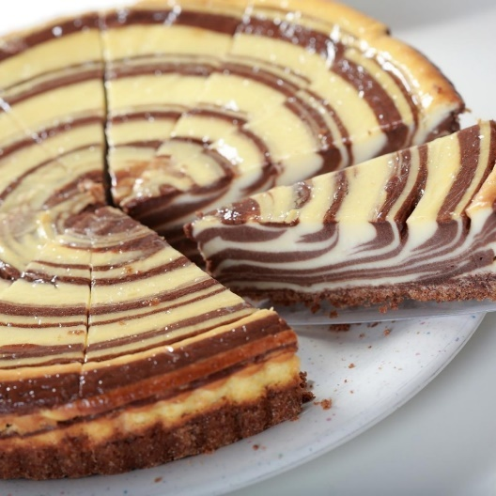
Unit 1: AC1.1-4
Hospitality Industry
LO1: Understand the environment in which hospitality and catering providers operate.
Marks: 15-29 |  | 17% – 32%
AC1.1 | AC1.2 | AC1.3 | AC1.4
Describe the structure of the hospitality and catering industry. | Analyse job requirements within the hospitality and catering industry. | Describe working conditions of different job roles across the hospitality and catering industry. | Explain factors affecting the success of hospitality and catering providers.
My Hospitality and Catering Business Proposal Part 6
Name: ............................................. Target Grade…………………………

Take off task ……..

List as many overheads you can think of that a hotel with a restaurant may have.

AC1.4: Explain factors affecting the success of hospitality and catering providers.

To get funding for a new business you would need to prove that you understand factors that can mean that you make a profit or make a loss. If you make a loss your business is not successful and you would not be able to pay back any loans. Banks will not lend money to businesses that are too risky. Having someone in charge that does not understand the factors affecting success would be to high a risk and a loan application would not be successful.

You must know about:
- Costs and costing
- Profit and factors that will influence you making a profit or loss
- The economy
- Environmental issues and trends
- Technology and technological advances
- Emerging and innovative cooking techniques
- Customer demographics and lifestyle and expectations
- Customer service and service provision generally
- Competition
- Trends- social and economic
- Political factors and legislation
- Media influences including social media and publicity

AC1.4: Costings
Produce a mind map of all the expenses that you would have when running your hotel. Expenses are all the things you would have to pay for on order to run your business. Expenses are also referred to as overheads.

Make sure you organise your ideas in a way that it would be easy for the bank manager to understand.

Expenses and overheads when running a hotel. £££££

AC1.4: Calculating Profit
If The Fat Duck restaurant had an average sales income of £2000.
The Fat Duck has a total food cost each week of £600.
Jamie’s Italian had an average sales income of £4000.
Jamie’s Italian has a total food cost each week of £1500.
What is each café’s gross profit?
Have they both met their target food cost, at 30% of sales income?

Café | Gross Profit | 30% Food Cost
Fat Duck | £1400 | £2000 x 0.3 = £
Jamie’s | £2500 | £4000 x 0.3 = £
Now can you work it out?

Explain why a business that takes the most money is not necessarily the one that is most successful (makes the most profit).
………………………………………………………………………………………………………………………………………………………………………………………………………………………………………………………………………………………………………………………………………………………………………………………………………………………………………………………………………………………………………………………………………………………………………………………………
When other costs are included, such as labour costs and overhead costs, what is the net profit of these two businesses?

 | The Fat Duck | Jamie’s Italian
Sales Income | £2000 | £4000
Labour costs per week | - £500 | - £1200
Overhead costs per week | - £400 | - £500
Food Costs | - £600 | - £1500
Total Costs
Net Profit
% of Sales Income
- What is their net profit in £s?

- What is their net profit as a percentage of their sales income?

- Who is the most successful?

The Executive Chef that you have hired to run your restaurant has written a 3-course set menu, and calculated overheads. How much would you have to charge customers to make sure that you made at least 20% profit
Item | Cost per cover (1 person)
Labour | £4
Overheads | £2
Food costs (ingredients) | £4
Total | £10
Add 20% profit
Add 20% Vat

I would have to charge customers ……………………………………………………………………
AC1.4: Costing Dishes - Homework or extension task

What is the most you think customers would be willing to pay? Give reasons for your answer. Make sure you research competitors’ prices to back up what you say.
………………………………………………………………………………………………………………………………………………………………………………………………………………………………………………………………………………………………………………………………………………………………………………………………………………………………………………………………………………………………………………………………………………………………………………………………
What is the most profit you think you could make from a 3 course set menu?
………………………………………………………………………………………………………………………….

Do you think your restaurant could be successful offering this set menu? Give reasons for your answer.
………………………………………………………………………………………………………………………………………………………………………………………………………………………………………………………………………………………………………………………………………………………………………………………………………………………………………………

AC1.4: Portion Control

What is meant by the term portion control?
………………………………………………………………………………………………………………………………………………………………………………………………………………………………………………………………………………………………………………………………………………………………………………………………………………………………………………

Why is portion control so important?
Produce a spider diagram to show all the reasons why portion control is important.

Why is portion control important?

AC1.4: Portion Control
Explain how you would create equal portions of the following products? Make sure it is clear what methods and tools and equipment you would use.
Dish | Portion Control

Ice Cream
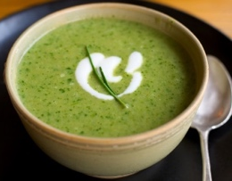

Soup

Gateaux
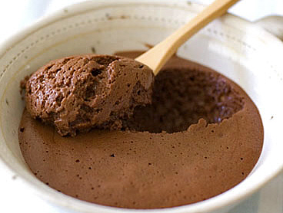

Mousse

Lasagne

Roast beef

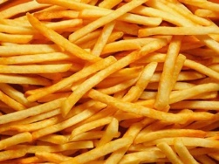
French Fries
Cupcakes
AC1.4: Portion Control Equipment
EXAM PRACTICE

Answer the following questions:
2. Portion control is very important in catering.
(a) How could portions of the following foods be controlled in a school canteen? (3 marks)
(i) Lasagne ...........................................................................................
(ii) Mashed potato ..............................................................................
(iii) Sauces and soups .........................................................................

(b) State three benefits of good portion control to the caterer. (3 marks)
- ...........................................................................................................
- ...........................................................................................................
- ...........................................................................................................
3. Discuss the importance of consistent portion control of desserts
to both the customer and hotel. (4 marks)
.............................................................................................................................................................................................................................................................................................................................................................................................................................................................................................................................................................................................................................................................................................
4. During an interview for the job, the chef is asked why portion control is important.
Discuss the main points that could be included in the answer. (4 marks)
..............................................................................................................................................................................................................................................................................................................................................................................................................................................................................................................................................................................................................................................................................................

