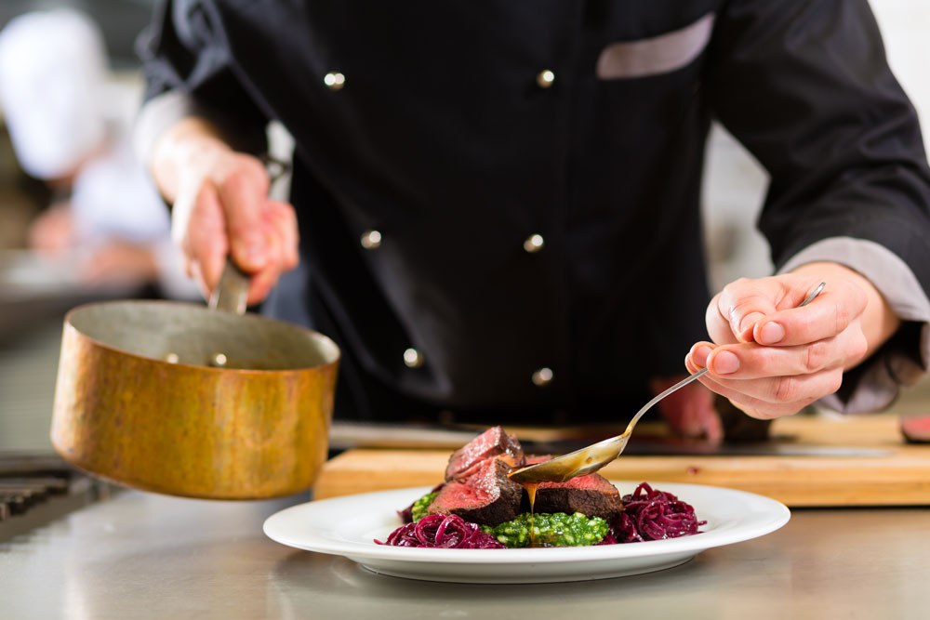
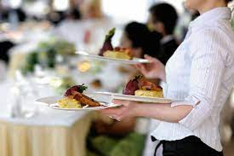
Unit 1: AC1.1-4
Hospitality Industry
LO1: Understand the environment in which hospitality and catering providers operate.
Marks: 15-29 |  | 17% – 32%
AC1.1 | AC1.2 | AC1.3 | AC1.4
Describe the structure of the hospitality and catering industry. | Analyse job requirements within the hospitality and catering industry. | Describe working conditions of different job roles across the hospitality and catering industry. | Explain factors affecting the success of hospitality and catering providers.
My Hospitality and Catering Business Proposal Part 2
Name: ............................................. Target Grade…………………………

There are many different ways food can be served. Which factors do you think you need to consider before deciding on a type of food service for your establishment?

AC1.1: Hospitality Chains
Hospitality Chains mean that the company has many establishments in a variety of places. This can be:
- Regional -just in one area.
- National- across the whole country.
- International- in more than one country, often across many countries or even continents.
To show you understand the Hospitality and Catering industry you would need to show that you have understood the advantages and disadvantages of being part of a chain.
Advantages | Disadvantages

AC1.1: Hospitality Chains
The following are all logos from well known Hospitality and Catering chains. To show you understand the industry you will need to classify them as residential or non-residential. They are all commercial and intend to make a profit.

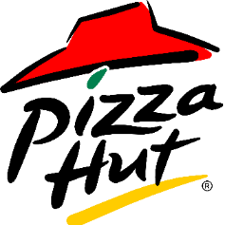……………………………….. ………………………………..

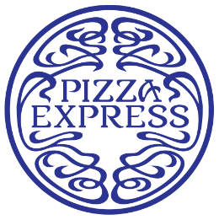……………………………….. ……………………………………

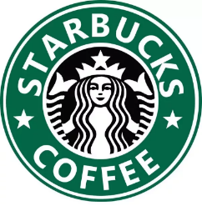…………………………………… 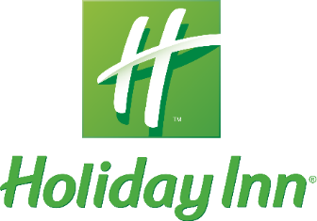 …………………………………………
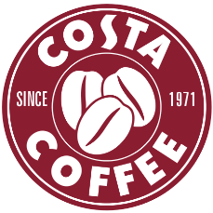…………………………………….. 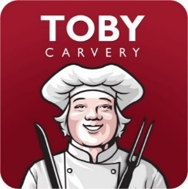………………………………………………

What other popular Hospitality and Catering Chains have you heard of?

Chains

AC1.1: Types of Service
When you could open your Hotel you could pick from a variety of types of service. Show that you understand this concept by naming the type of service that is described.

Type of service ………………………………………………………………………………………………………………..
- Meals are pre-plated in the kitchen.
- Good portion control methods.
- All plates are consistent in the food presentation.
- The method relies more on skilled kitchen staff than skilled serving staff.
- Time consuming for the kitchen staff.
- Price varies depending on the standard of presentation.
- A high standard of presentation increases the selling price.

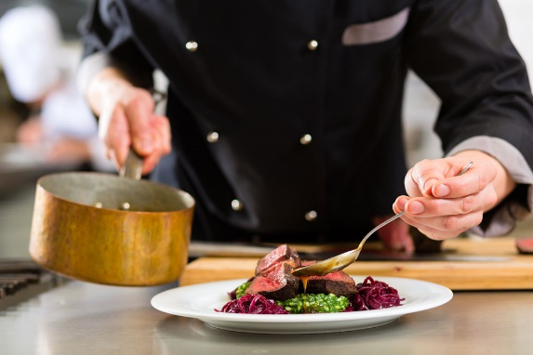

What establishments can you think of that use this type of service?
……………………………………………………………………………………………………………………………………………………………………………………………………………………………………………………………………………………………..

Type of service ………………………………………………………………………………………………………………..

- The food is placed on the table, spoons are provided and customers serve themselves.
- It is a sociable method and it is easy and quick to serve.
- It requires larger tables.
- There is less portion control.
- There can be more waste.
- The method is often used for serving vegetables for Sunday Lunch for e.g.
- It suits families.

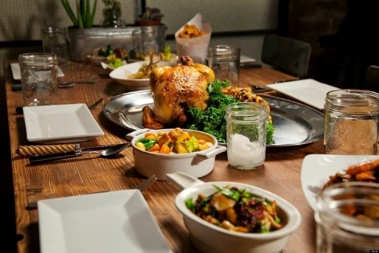

What establishments can you think of that use this type of service?
……………………………………………………………………………………………………………………………………………………………………………………………………………………………………………………………………………………………..

Type of service …………………………………………………………………………………………………………………
- This type of service requires more training for wait staff, it is a skill.
- Food is fully cooked in the kitchen but presented on platters.
- A silver spoon and fork are used to serve food from a platter to a guest’s plate at a table.
- It is often used in very prestigious locations.
- The waiter/waitress holds the spoon and fork in one hand and uses them to hold the food and transfer it from the platter to the plate.
- The hot dinner plates are put onto the table just before serving the food.
- There are strict rules and etiquette to follow when serving the food.

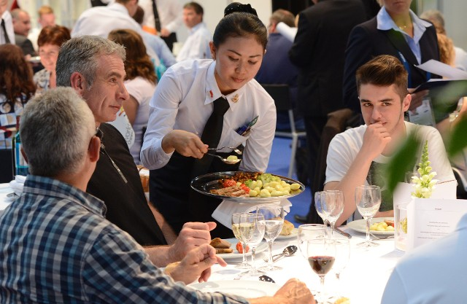
What establishments can you think of that use this type of service?
………………………………………………………………………………………………………………………………………………………………………………………………………………………………………………………………………………………………

Type of service ………………………………………………………………………………………………………………….
- Food is cooked, finished or presented to the guest at a table, from a moveable trolley.
- The food being served is usually partially or mostly prepared in the kitchen.
- The waiter then does the final assembly or cooking on the trolley at the side of the restaurant customer's table.
- This might involve flambéing an item, carving it, cooking on a hot stone/plate or tossing a salad.
- Ensures exact serving temperature.
- Turns food into entertainment and creates an atmosphere of sophistication.
- Less popular now as restaurant dining rooms have to be less crowded with enough space between tables for the trolley to move and be positioned.
- Dining room staff need to be specially trained in how to finish the dishes being offered.
- Restaurant customers could get bored with the same typical dishes offered, as they lose novelty over time.

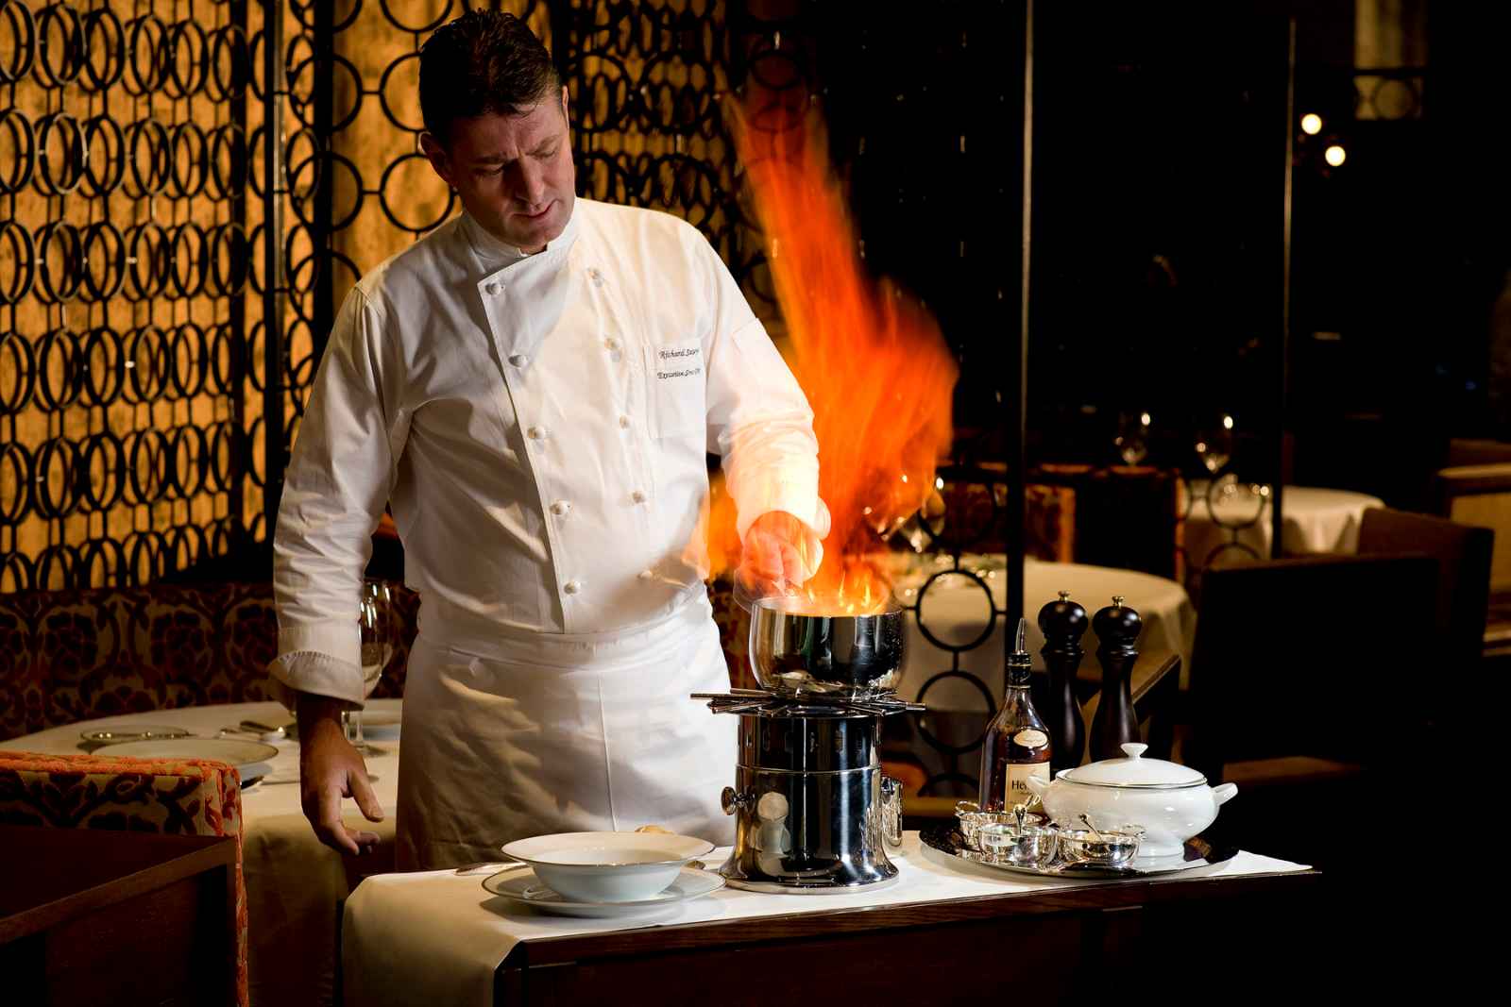

What establishments can you think of that use this type of service?
……………………………………………………………………………………………………………………………………………………………………………………………………………………………………………………………………………………………..

Type of service ………………………………………………………………………………………………………………….
- The food is prepared and cooked in the kitchen or sometimes bought in and just displayed or reheated.
- Counters displaying ready prepared/cooked food are used.
- Customers queue up.
- Simple basic experience for customers, not luxury/high end.
- High turnover and fast method of service.
- Low skill level needed for serving staff.
- Customers may impulse buy from the displays.
- Customers may buy less and skip areas if they get fed up of queuing.
- The length of the queue can influence customer satisfaction.

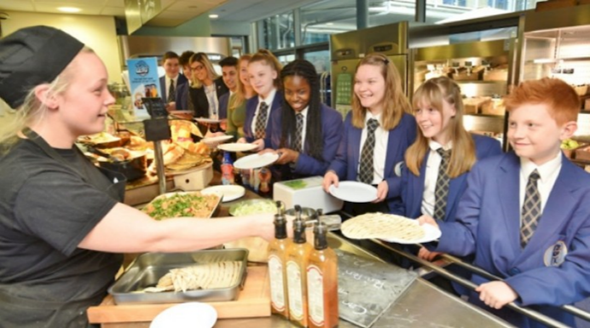

What establishments can you think of that use this type of service?
……………………………………………………………………………………………………………………………………………………………………………………………………………………………………………………………………………………………..

Type of service ………………………………………………………………………………………………………………….
- Food set up along a table.
- The food can be hot or cold.
- It can be self-service or served by staff, or a mixture of the two.
- Less formal than plated or silver service.
- It is a fast and simple method.
- Can be low cost depending of the food served and the amount of staff.
- Poor portion control when people help themselves and can go back for more.
- Customers can spoil the appearance of the food.
- Harder to know how much to make as customers appetites varies.
- Can be a lot of waste.
- Higher risk of contamination and harder to control temperature when the food is uncovered.
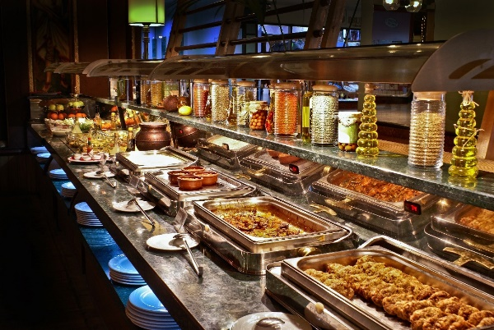
What establishments can you think of that use this type of service?
………………………………………………………………………………………………………………………………………………………………………………………………………………………………………………………………………………………………

Type of service …………………………………………………………………………………………………………………
- A Take-away service with the option to eat in.
- Customers collect food from a counter.
- Quick and simple method.
- Can have a high customer turnover/serve lots of customers quickly.
- Often limited menu choice.
- Kitchen staff do not have to be skilled chefs.
- Food is often pre-prepared and re-heated or cooked and kept hot
- Food served in disposable packaging.
- Packaging is bad for the environment.
- Can be enjoyable for customers but not high end/luxury service.
- A method favoured by younger people.
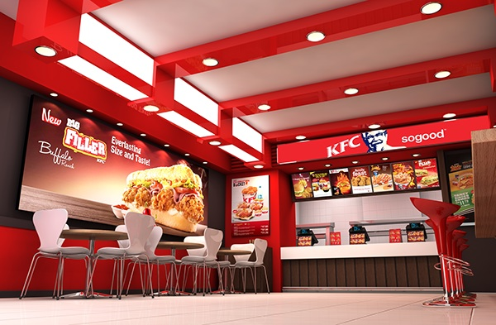
What establishments can you think of that use this type of service?
……………………………………………………………………………………………………………………………………………………………………………………………………………………………………………………………………………………………..

Type of service …………………………………………………………………………………………………………………
- Gueridon uses elements of this type of service too, but is more high end/luxury.
- Room service may also include elements of this type of service.
- A meal provided in a tray or a choice of food from a trolley.
- Menu options are often limited and sometimes customers order in advance.
- Food can be prepared elsewhere and reheated or made in the premises and moved to another area on the trolley.
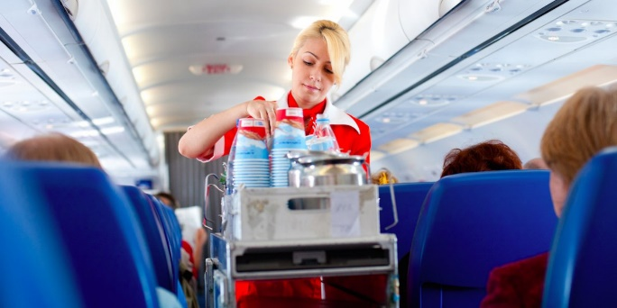
What establishments can you think of that use this type of service?
……………………………………………………………………………………………………………………………………………………………………………………………………………………………………………………………………………………………..

Type of service …………………………………………………………………………………………………………………
- Food service from a machine.
- Food can be served 24 hours.
- Usually snacks are served in this way but it can also be hot meals.
- Menu options are limited to well packaged items that are not easily damaged.
- Staffing is minimal and they do not need a large amount of training.
- Inexpensive and not luxury/high-end.
- Prone to errors/jams so customers can be dissatisfied.
- Sometimes get an item that has got stuck as well as what they have paid for.
- Good for impulsive/boredom buys.
- The amount of packaging and electricity used 24/7 is bad for the environment.

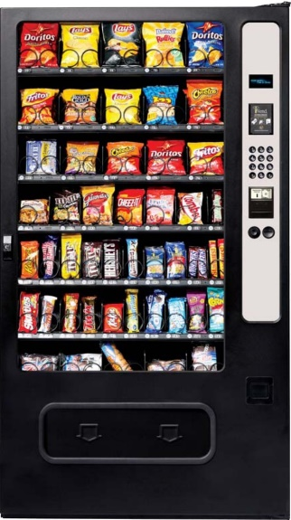
What establishments can you think of that use this type of service?
………………………………………………………………………………………………………………………………………………………………………………………………………………………………………………………………………………………………

Type of service ………………………………………………………………………………………………………………….
- Delivered to a house/home usually.
- Can be ordered from an establishment that also offers take-away service.
- Some places just specialise in home delivery.
Sometimes there is an additional delivery/service charge.
- Insulated bags/containers are used to keep food hot or cold.
- Packaging and fuel use are bad for the environment.

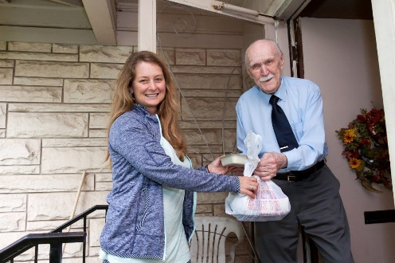
What establishments can you think of that use this type of service?
………………………………………………………………………………………………………………………………………………………………………………………………………………………………………………………………………………………………

Write your own information about Take away service.
Type of service: Take away
- ………………………………………………………………………………………………………………………………………………………………………………………………………………………………………………………………………..
- ………………………………………………………………………………………………………………………………………………………………………………………………………………………………………………………………………..
- ………………………………………………………………………………………………………………………………………………………………………………………………………………………………………………………………………..
- …………………………………………………………………………………………………………………………………………………………………………………………………………………………………………………………………………
- ………………………………………………………………………………………………………………………………………………………………………………………………………………………………………………………………………….

AC1.1: Types of Service- factors
The type of service provided depends on what factors? Write all the factors that may influence the type of service offered in the space below:

Factors influencing service type

AC1.1: Describe the types of service
Describe the service shown in the video. Include who you think the main target user would be.
Justify your answers.

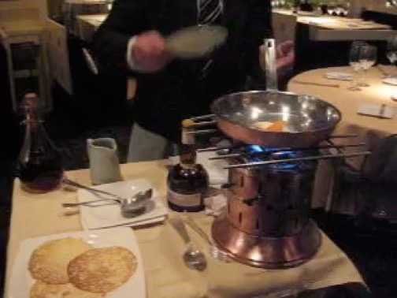
................................................................................................................................................................................................................................................................................................................................................................................................................................................................................................................................................................................................................................................................................................................................................................................................................................................................................................

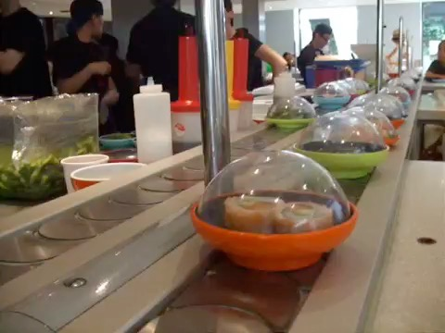
................................................................................................................................................................................................................................................................................................................................................................................................................................................................................................................................................................................................................................................................................................................................................................................................................................................................................................

AC1.1: Types of service Advantages/Disadvantages

Fill in the following table to show you understand the advantages and disadvantages of each type of service

Type of service | Advantages/Positives | Disadvantages/Negatives
Plated
Family
Silver
Gueridon
Cafeteria
Buffet
Fast Food
Tray or trolley
Vended
Home delivery
Take away

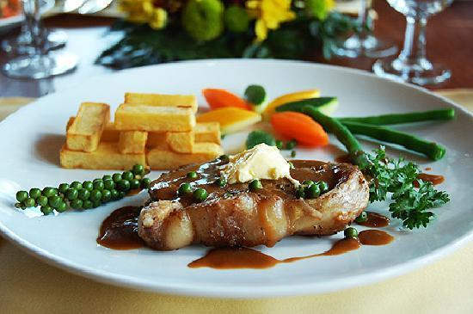

What type of service styles would you use in your hotel? Explain how and why you would use that type of service.
……………………………………………………………………………………………………………………………………………………………………………………………………………………………………………………………………………………………………………………………………………………………………………………………………………………………………………………………………………………………………………………………………………………………………………………………………………………………………………………………………………………………………………………………………………………………………………………………………………………………………………………………………………………………………………………………………………………………………………………………………………………………………………………………………………………………………………………………………………………………………………………………………………………………………………………………………………………………………………………………………………………………………………………………………………………………………………………………………………………………………………………………………………………………………………………………………………………………………………………………………………………………………………………………………………………………………………………………………………………………………………………………………………………………………………………………………………………………………………………………………………………………………………………………………………………………..

