Unit 1: AC1.1-4
Hospitality Industry
LO1: Understand the environment in which hospitality and catering providers operate.
Marks: 15-29 |  | 17% – 32%
AC1.1 | AC1.2 | AC1.3 | AC1.4
Describe the structure of the hospitality and catering industry. | Analyse job requirements within the hospitality and catering industry. | Describe working conditions of different job roles across the hospitality and catering industry. | Explain factors affecting the success of hospitality and catering providers.
My Hospitality and Catering Business Proposal Part 1
Name: ............................................. Target Grade…………………………

Take off task ……..
Think about your local area. How many restaurants, hotels, pubs, shops and leisure centres can you name. Make a list.

AC1.1: Describe the structure of the

Hospitality and catering industry.

To receive funding for a new business you would be expected to show that you understand the industry area that you are going to be working in. You are trying to get funding for a new hotel with a bar and restaurant.

You must know about:
- Types of provider
- Types of service
- Commercial establishments
- Non-commercial catering establishments
- Services provided
- Suppliers
- Where hospitality is provided
at non-catering venues
- Standards and ratings
- Job roles within the industry

What is hospitality and catering? Write the definitions in the space below.
Hospitality ………………………………………………………………………………………………………………………………………………………………………………………………………………………………………………………………………………………………………………………………………………………………………………………………………………………........................................................................
Catering ……………………………………………………………………………………………………………………………………………………………………………………………………………………………………………………………………………………………………………………………………………………………………………………………………………………...........................................................................
Additional information to help explain what Hospitality and catering involves. ………………………………………………………………………………………………………………………………………………………………………………………………………………………………………………………………………………………………………………………………………………………………………………………………………………………………………………………………………………………………………………………………………………………………………………………………………………………………………………………………………………………………………………………………………………………………………………………………………………………………………………………………………………………………………………………………………………………………………………
Provide evidence that the hospitality and catering industry is commercially viable and a worldwide industry. …………………………………………………………………………………………………………………………………………………………………………………………………………………………………………………………………………………………………………………………………………………………………………………………………………………………………………………………………………………………………………………………………………………………………………………………………………………………………………………………………………………………………………………………………………………………………………………………………………………

AC1.1: Influences affecting the hospitality industry

Produce a spider diagram or mind map to show all of the factors that could influence your business.

Factors

AC1.1: Sectors of the hospitality industry

Use this page to show all the different business types that are considered to be sectors of the hospitality and catering industry. You may use text or images (including photographs). Make sure images are clearly labelled.

AC1.1: Establishment Types

Remember that you need to answer all the following questions in the context of hospitality and catering not a domestic (home) description.

What is the definition of a residential establishment?
……………………………………………………………………………………………………………………………………………………………………………………………………………………………………………………………………………………………………………………………………………………………………………………………………………………….....................................................................

What is the definition of a non-residential establishment?
……………………………………………………………………………………………………………………………………………………………………………………………………………………………………………………………………………………………………………………………………………………………………………………………………………………….....................................................................

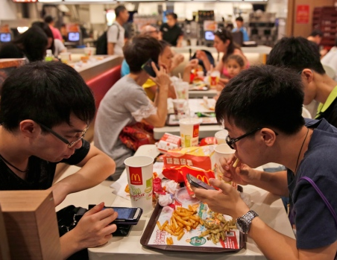
What is the definition of commerical?
……………………………………………………………………………………………………………………………………………………………………………………………………………………………………………………………………………………………….................................................
What is the definiton of non-commercial?
……………………………………………………………………………………………………………………………………………………………………………………………………………………………………………………………………………………………….................................................
What is the definition of profit?
……………………………………………………………………………………………………………………………………………………………………………………………………………………………………………………………………………………………....................................................
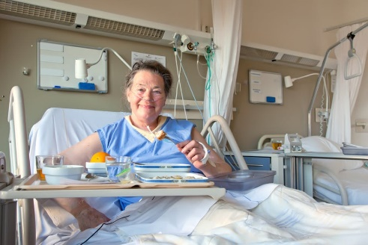

AC1.1: Commercial establishments
Use this page to show the range of commercial establishments that are in the hospitality and catering sector. Divide them into residential and non-residential.

Residential profit-making establishments | Non-residential profit making establishments

AC1.1: Non-commercial establishments

Use the space below to show the range of Non- commercial establishments that are in the hospitality and catering sector. Divide them into residential and non-residential.

Residential non-profit making establishments | Non-residential non-profit making establishments

My hotel will be ………………………………………………............. and …………………………………………………
Words to help
Residential Non-residential Commercial Non-commerical

AC1.1: Establishments-Task
In the space below create a mind map of all the hospitality catering establishments in your local area.
Decide if they are residential, non-residential, commercial, non-commercial or contract caterers.

A competitor in the hospitality and catering industry is another business or organisation that could potentially have the same customers as you. They could choose to use you or your competitors establishments.
From the establishments identified in your spider diagram, in your local area, who would be your 3 biggest competitors? Explain why you would be in competion with them?
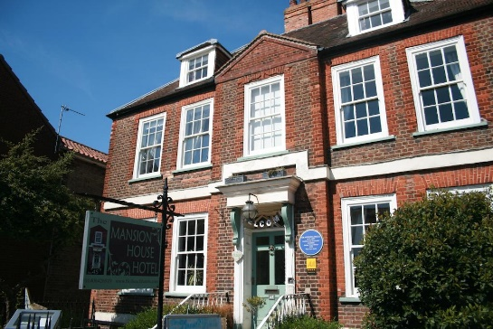

Competitor 1…………………………………………………………………………………………………………………………
Reason ……………………………………………………………………………………………………………………………………………………………………………………………………………………………………………………………………………………………………………………………………………………………………………………………………………………………………………………………………………………………………………………………………………………………………………………………………………………………………………………………………………………………………………………………………………..............................................................................................................................

Competitor 2…………………………………………………………………………………………………………………………
Reason ……………………………………………………………………………………………………………………………………………………………………………………………………………………………………………………………………………………………………………………………………………………………………………………………………………………………………………………………………………………………………………………………………………………………………………………………………………………………………………………………………………………………………………………………………………..............................................................................................................................

Competitor 3…………………………………………………………………………………………………………………………
Reason ……………………………………………………………………………………………………………………………………………………………………………………………………………………………………………………………………………………………………………………………………………………………………………………………………………………………………………………………………………………………………………………………………………………………………………………………………………………………………………………………………………………………………………………………………………..............................................................................................................................

The hospitality industry can be divided into:
The hospitality business sector | The catering/hospitality services sector
 | 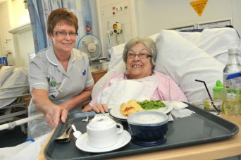
Comprising establishments that provide food, drink and accommodation in exchange for money; they are run as a business and their main reason for operating is to provide these products and services and make a profit. | where accommodation and catering are not the main business, but these secondary or indirect services are still needed by customers, residents, staff and/or visitors; the services are often subsidised or offered at cost price.

If you were to open your hotel, which of the sectors above would it be in and why?
……………………………………………………………………………………………………………………………………………………………………………………………………………………………………………………………………………………………………………………………………………………………………………………………………………………………………………….........................................................................
What hospitality and catering services would you expect your hotel to provide for customers?

Hospitality and catering services for hotel customers.

AC1.1: Contract Caterers
Use the space below to display the main facts associated with Contract Caterers.

What are contract caterers and what do they provide?

Disadvantages
Advantages

Peter’s company is very successful.
Evaluate the factors that contribute to the success of a contract catering company. (10 Marks).
.............................................................................................................................................................................................................................................................................................................................................................................................................................................................................................................................................................................................................................................................................................................................................................................................................................................................................................................................................................................................................................................................................................................................................................................................................................................................................................................................................................................................................................................................................................................................................................................................................................................................................................

Your hotel will have its own kitchen but think of all the reasons why you may also need to hire contract caterers too. ……………………………………………………………………………………………………………………………………………………………………………………………………………………………………………………………………………………………………………………………………………………………………………………………………………………………………………………………………………………………………………………………………………………………………………………………………………………………………………………………………………………………………………………………………………………………………………………………………………………………………………………………………………………………………………………………………………………………………………………………………………………………………………………………………………………………………………………………………………………………………………………………………………………………………………………………………………………………………………………………………………………………………………………………………………….............................................................
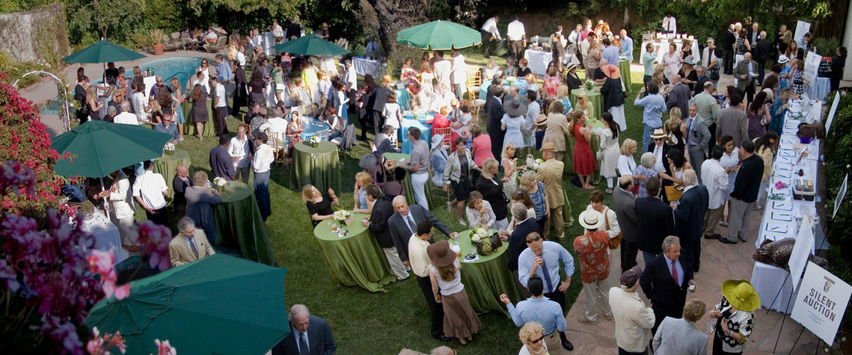

AC1.1: Outdoor Catering

What are the risks of using your hotel grounds (gardens) for holding a catered event?
………………………………………………………………………………………………………………………………………………………………………………………………………………………………………………………………………………………………………………………………………………………………………………………………………………………………………………………………………………………………………………………………………………………………………………………………………………………………………………………………………………………………………………………………………………………………………………………………………………………………………………………………………………………………………………………………………………………………………………………………………………………………………………………………………………………………………………………………………………………………………………………………………………………………………………………………………………………………………………………………………………………………………………………………………………………………………………………………………………………………………………………………………………………………………………………………………………………………………………………………………………………………………………………………………………………………………………………………………………………………………………………………………………………………………...

AC1.1: Suppliers

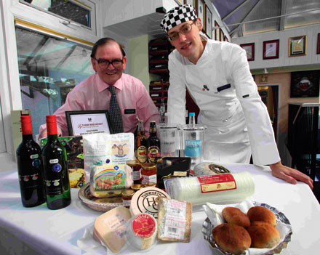
What standards would you expect from someone supplying your hotel?
…………………………………………………………………............................
……………………………………………………………………………………………
……………………………………………………………………………………………
……………………………………………………………………………………………
…………………………………………………………………………………………..
…………………………………………………………………………………………..

Local sourcing is very fashionable and could gain you extra customers. Who do you know of locally that could be used as a supplier for your hotel?
………………………………………………………………………………………………………………………………………………………………………………………………………………………………………………………………………………………………………………………………………………………………………………………………………………………………………………………………………………………………………………………………………………………………………………………………………………………………………………………………………………………………………………………………………………………………………………………………………………………………………………………………………

What type of ingredients or items for your hotel do you think are best locally sourced?
……………………………………………………………………………………………………………………………………………………………………………………………………………………………………………………………………………………………………………………………………………………………………………………………………………………………………………………………………………………………………………………………………………………………………………………………….................................................................................................

What types of ingredients or items do you think would need to be sourced from outside your local area?
……………………………………………………………………………………………………………………………………………………………………………………………………………………………………………………………………………………………………………………………………………………………………………………………………………………………………………………………………………………………………………………………………………………………………………………………....................................................................................................

